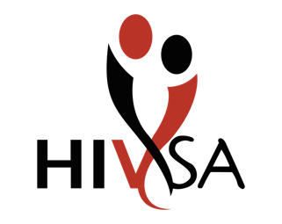

COURSE APPLICATION FORM - INDIVIDUAL

|  |
| --- |
| Please complete the application in full, using CAPITAL letters.  Read the Terms and Conditions on the second page. |

|  |  |
| --- | --- |
| COURSE: |  |
| DATE: |  |
| VENUE: |  |

|  |  |
| --- | --- |
| Name and Surname |  |
| ID number |  |
| Physical address |  |
| Postal code |  |
| Telephone number |  |
| Cell phone number |  |
| Email address |  |
| Highest level passed |  |

PARTICIPANT’s SPECIAL NEEDS

|  |  |  |  |
| --- | --- | --- | --- |
| Catering (X on that which is applicable) | Halaal | Vegetarian | Other |
| Any disabilities? (please state) | | | |
|  | | | |

Send your application form to:

1. Training Coordinator [training@hivsa.com](mailto:training@hivsa.com)
2. Contact number: 011 494 1900

**TERMS AND CONDITIONS**

1. Circumstances beyond the organiser’s control can necessitate the replacement of a trainer, cancellation or postponement of an event. Should an event be cancelled / postponed by HIVSA, HIVSA will issue a refund.
2. On receipt of your booking/registration, we will confirm receipt and issue a quote for acceptance. Once quote has been accepted, a Tax Invoice will be issued to effect payment.
3. **PUBLIC Courses.** Only once the minimum delegate number for the public workshop has been confirmed, will a tax invoice will be sent via email.
4. The full delegate fee must be paid before the workshop commences. There are no payment plans.
5. In the event of unforeseen circumstances, the organizer reserves the right to change the venue and or the dates.

**WHAT IF I HAVE TO CANCEL OR CHANGE DATES?**

1. If you cancel two (2) weeks or more prior to the event a 10% cancellation fee will be levied. Thereafter the full fee is payable.
2. If you cancel less than two (2) weeks prior to the workshop, you may:

a) Request a new date;

b) Incur a 100 % of the fees paid;

1. Only written cancellations will be accepted;
2. If no written cancellation is received, you are liable for 100% of the cost of the workshop.

**I agree to the above terms and conditions**

**Banking Details**

ABSA Bank

Account name: HIV SA

Account number:

Branch Code: 632005

Account Type: Cheque

Swift address: ABSAZAJJ